SIMATS ENGINEERING (SAVEETHA SCHOOL OF ENGINEERING)
Department of Computer Science and Engineering
ASSESSMENT TOOL 2 – SCENARIO BASED ASSESSMENT (2 Questions)

Course Code: |  | ITA05 | Course Title: | COMPUTER VISION
CO Assessed: |  | CO2 – Manipulation (BL3) | Assessment: | Assessment Tool 2 – Scenario Based Assessment
Weightage: |  | 20% of CIA | Total Marks: | 20 (2 Questions × 10 Marks)
CO5 Statement: |  | Apply image enhancement and segmentation techniques for extracting meaningful regions from images.(BL3)
Student Name: |  | CHAVALI CHANDU | Reg. No.: | 192472332
Section / Batch: |  | SLOT D | Date:
Code of Conduct
I (Name / Reg No) certify that this submission is my original work and that I have adhered to the guidelines specified for this assessment. I understand that any violation of academic integrity rules will result in disciplinary action.

Signature of the Student:

Instructions
- This test contains 2 questions, each carrying 10 marks. Total: 20 Marks.
- No negative marking. Unanswered questions carry zero marks.
- No calculators or electronic devices permitted.
- Duration: 60 minutes.
Section / Topic | Focus Area | Q. Nos. Marks
Frequency Domain Image Enhancement | Periodic noise removal, Fourier Transform, notch filtering, quality inspection | 1 | 10
Spatial Filtering & Edge-Preserving Enhancement | Bilateral filtering, edge preservation, autonomous vehicle navigation | 2 | 10
GRAND TOTAL: |  | 20 Marks
Annexure A – Scenario Based Assessment

Scenario 1: Manufacturing Quality Inspection
An automated quality inspection system captures images of metal components. Electrical interference introduces repetitive horizontal stripes across the images, making defect detection unreliable.
- Interpret the scenario and identify the type of noise present.
- Explain how this degradation affects inspection accuracy.
- Recommend an appropriate enhancement technique to remove the interference.
- Justify why your selected approach is more suitable than spatial-domain methods.(e) Explain your answer in a logical sequence.

Interpretation & Type of Noise:
In this scenario, an automated inspection system captures images of metal components, but the images contain repetitive horizontal stripes due to electrical interference.
This pattern clearly indicates the presence of Periodic Noise (Structured Noise). Unlike random noise (Gaussian or salt-and-pepper), periodic noise appears as regular repeating patterns, often caused by:
    - Electrical interference in sensors
    - Power supply fluctuations
    - Transmission disturbances
Mathematically, periodic noise can be represented as sinusoidal interference added to the image signal. It is not random, but structured and predictable.

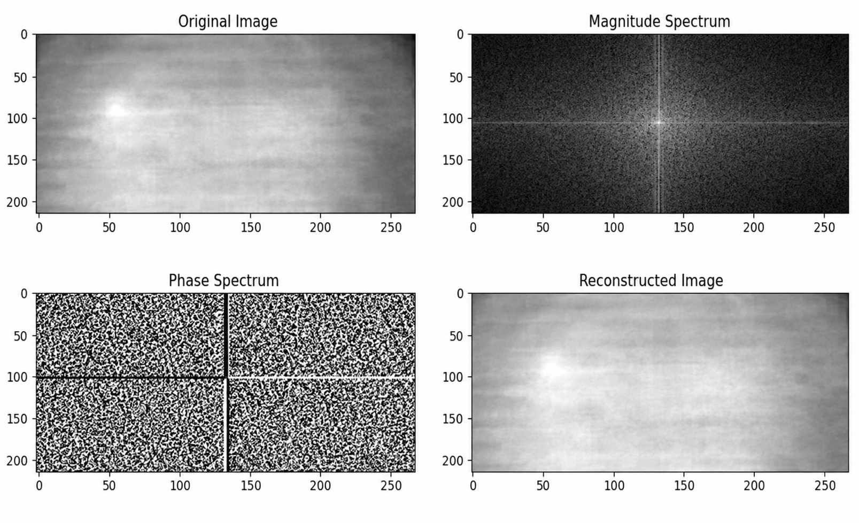

Effect on Inspection Accuracy:
Periodic noise significantly degrades the inspection system:
- False Defect Detection
The stripes may resemble cracks or scratches, leading to false positives.
- Hidden Real Defects
Actual defects may be masked by the noise pattern.
- Reduced Edge Clarity
Important boundaries of components become blurred or distorted.
- Poor Feature Extraction
Machine learning models rely on clean features—noise corrupts them.

- Lower Reliability of Automation
The system becomes inconsistent, reducing trust in automated inspection.

Recommended Enhancement Technique:
The most effective method is:
Frequency Domain Filtering using Notch Filter Steps:
- Convert image to frequency domain using Fourier Transform (FFT)
- Identify bright spots corresponding to periodic noise
- Apply Notch Filter to remove those frequencies
- Convert back using Inverse FFT
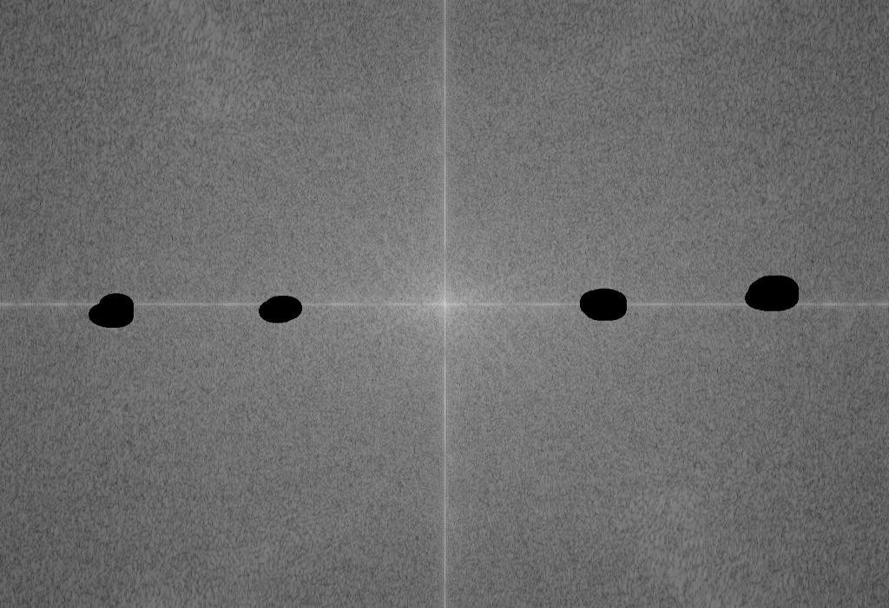

(e) Justification: Why Frequency Domain is Better:

Aspect | Frequency Domain (Notch Filter) | Spatial Domain
Noise  Removal | Targets exact frequencies | Affects entire image
Precision | High (removes only noise) | Low (blurs image)
Edge  Preservation | Maintained | Often degraded
Suitability | Best for periodic noise | Not suitable

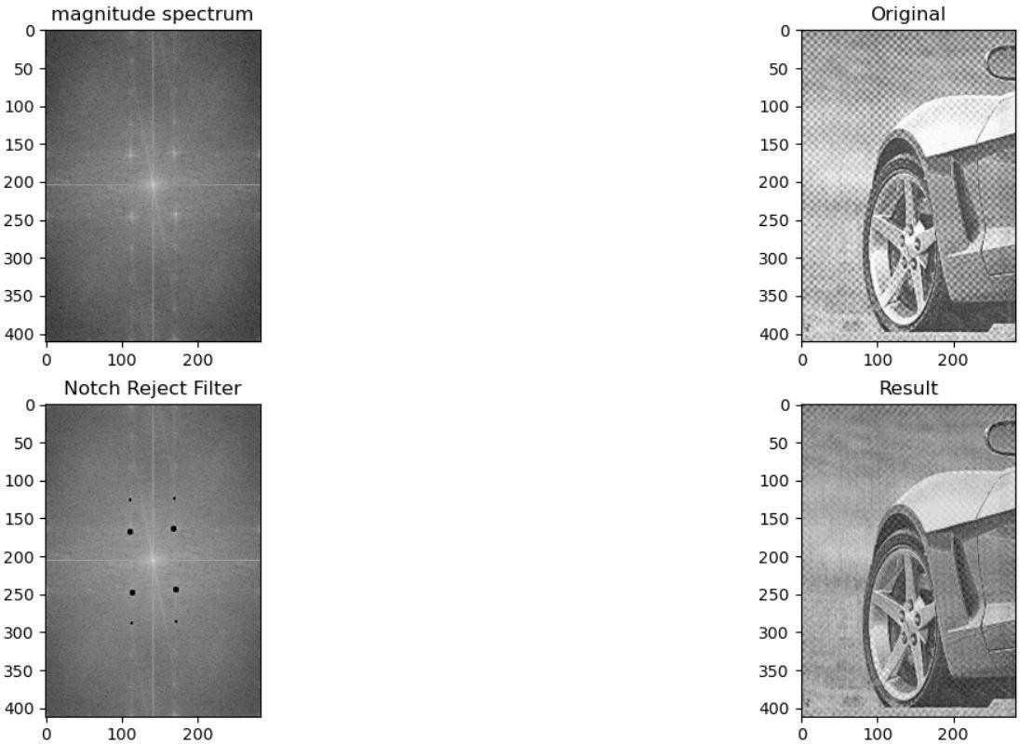

Scenario 2: Autonomous Vehicle Navigation
A self-driving car captures road images during heavy rain. Although noise is present, the lane markings and road edges must remain sharp for safe navigation.
- Interpret the scenario and explain the challenge involved.
- Identify the importance of preserving edges while removing noise.
- Recommend a suitable filtering technique.
- Justify why your selected filter preserves important image details.

Interpretation & Challenge:
In this scenario, a self-driving car captures road images during heavy rain.
Challenges include:
  - Presence of random noise (rain droplets, sensor noise)
  - Reduced visibility
  - Need to clearly detect lane markings and road edges The core problem is:
👉 Remove noise while preserving important edges


Importance of Edge Preservation:
Edges are critical for autonomous navigation:
- Lane Detection
Lane markings guide vehicle movement.
- Road Boundary Identification
Prevents the car from going off-road.
- Object Detection
Edges define vehicles, pedestrians, obstacles.
- Decision Making
AI models rely on clear structural features.
⚠️ If edges are blurred:
  - Lane detection fails
  - Navigation becomes unsafe
  - Accidents may occur

- Recommended Filtering Technique: Bilateral Filter (Edge-Preserving Filter) The bilateral filter:
  - Smooths noise
  - Preserves edges
  - Uses both spatial and intensity information

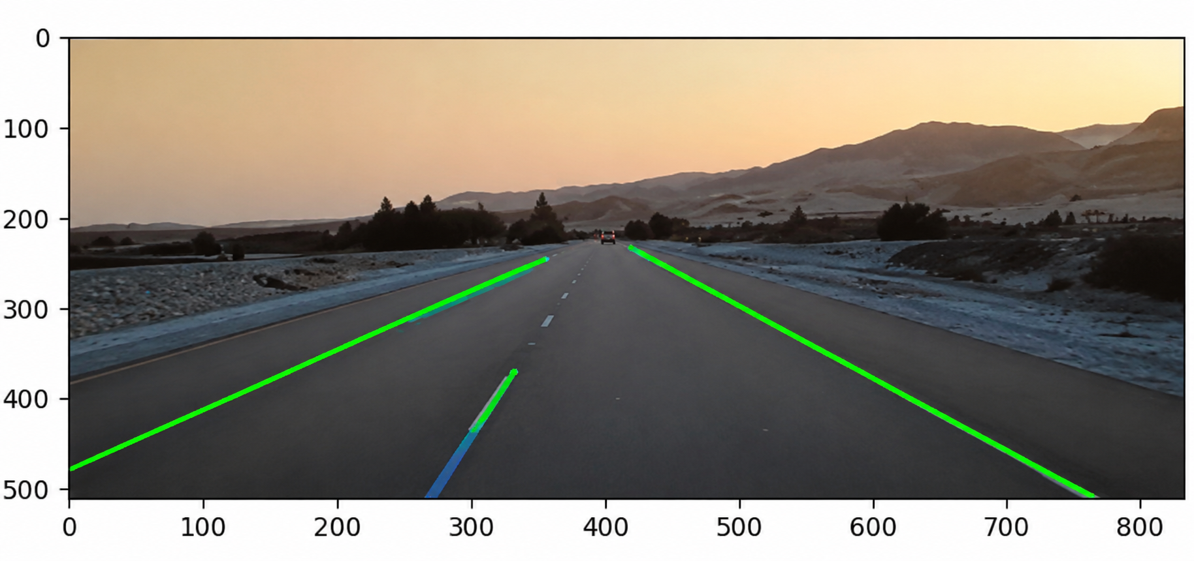

Justification: Why Bilateral Filter Works:

Feature | Bilateral Filter | Gaussian Filter
Noise Removal | Good | Good
Edge Preservation | Excellent | Poor
Blur Effect | Minimal | High
Suitability | Best for navigation | Not suitable

Why it works:
  - It considers pixel similarity + distance
  - Does not average across edges
  - Keeps sharp transitions intact
Thus, lane markings remain clear even after filtering

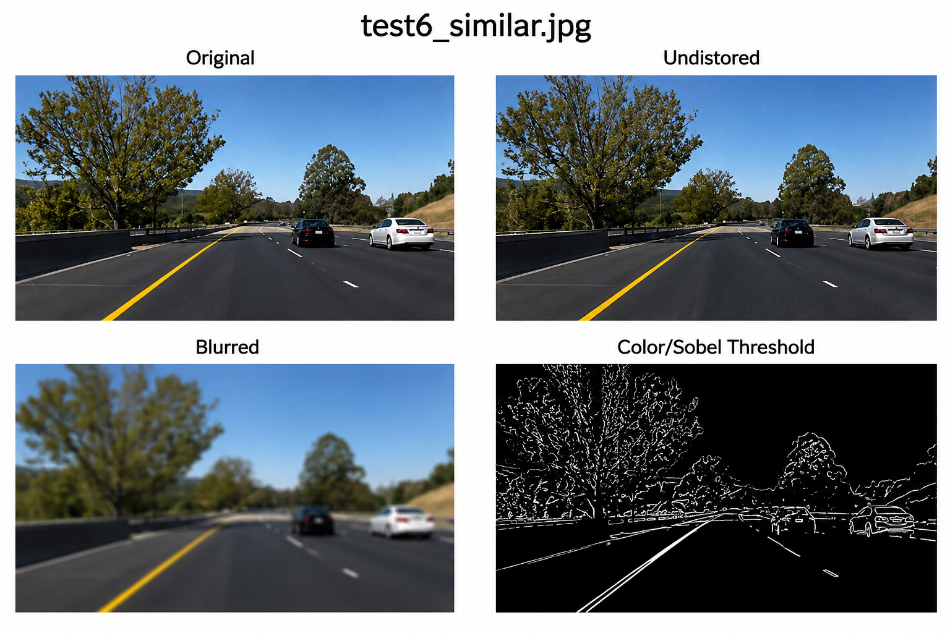

Present your explanation clearly and systematically:
Systematic Explanation:
- Problem Identification:
A self-driving car captures road images during heavy rain, introducing random noise and distortions.
- Nature of Challenge:
  - Rain causes visibility issues and noise
  - Critical features like lane markings and road edges must remain clear
- Importance of Image Features:
  - Lane markings guide vehicle movement
  - Road edges define safe boundaries
  - These features are essential for navigation decisions
- Risk of Improper Processing:
  - Standard smoothing filters may blur edges
  - Loss of edge information can lead to navigation errors
- Recommended Solution:
Use an edge-preserving filter, specifically the Bilateral Filter.
- Working Principle:
  - Considers both pixel distance and intensity similarity
  - Smooths noise while avoiding changes across edges
- Processing Steps:
  - Apply bilateral filtering on the noisy image
  - Reduce rain noise
  - Preserve sharp edges and lane markings
- Final Outcome:
  - Noise is reduced effectively
  - Edges remain sharp and clear
  - Improves accuracy of lane detection and ensures safe navigation

Rubrics for Calculation

 | Criteria |  | Weig htage (%) | Level 4 (Exemplary) |  |  | Level 3 (Proficient  ) |  | Level 2 (Developing) | Level 1 (Beginning) |  | Marks
 | Understanding of Scenario |  | 20% | Demonstrates clear and  complete |  |  | Shows good  understand |  | Partial understanding  ; misses key | Misinterprets or fails to understand
 |  |  |  | understanding of the scenario and context |  | ing with minor gaps |  | aspects |  | the scenario
Identification of Key Issues |  | 20% |  | Accurately identifies all relevant issues and factors  involved |  | Identifies most key issues with minor  omissions |  | Identifies limited issues; some irrelevant points |  | Unable to identify key issues
Application of Concepts |  | 25% |  | Applies appropriate concepts  effectively to address the scenario |  | Applies concepts with minor errors |  | Limited or partially correct application |  | Unable to apply relevant concepts
Decision Making |  | 20% |  | Makes wellreasoned, logical decisions with strong rationale |  | Makes reasonable decisions with some justification |  | Makes weak decisions with limited justification |  | No clear decisions made or rationale provided
Clarity of Response |  | 15% |  | Response is clear,  structured, and logically presented |  | Generally clear with minor issues |  | Somewhat unclear or poorly structured |  | Disorganized and difficult to understand
Faculty In-charge |  |  |  |  | Course Coordinator |  |  |  |  | Head of Department
Signature: |  |  |  |  | Signature: |  |  |  |  | Signature:
Date: |  |  |  |  | Date: |  |  |  |  | Date:

